Winners of Essay Competition

On the occasion of Fateha I Dowaz Daham, an essay competition was organized jointly by the Departments of Arabic and Hindi on the topic Role of Religion in Ensuring Communal Harmony on 19th September, 2024. Our 5th Semester Student Lotika Nath secured 1st position in the competition.
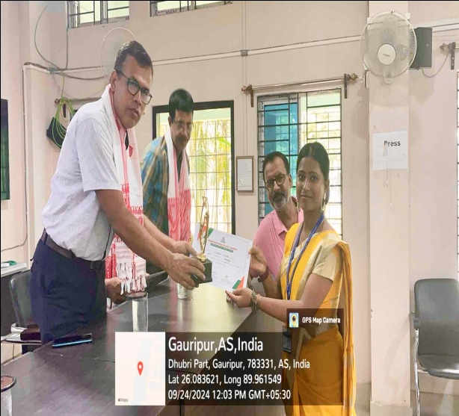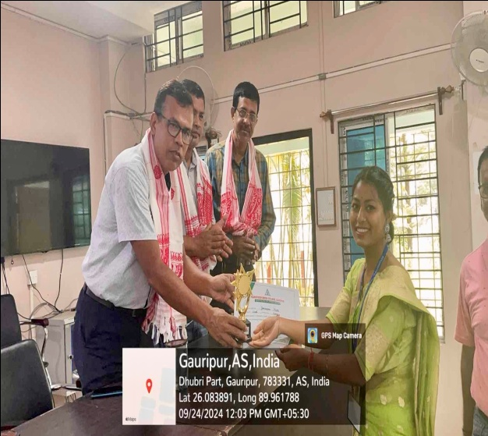
Lotika Nath receiving her award Jonmoni Nath receiving her award
Our student Jonmoni Nath from 5th Semester secured the second position. They were felicitated with a trophy and a certificate by the Principal and the Heads of Arabic and Hindi Dr A T Sheikh and Dr Sambhu Pandey.
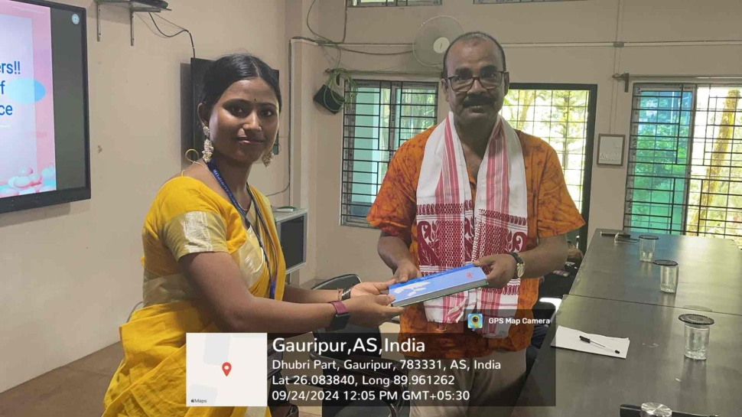
Impressed by her performance on various markers, Lotika was gifted a poetry book by Dr Jafar Wajeb, Head of the Department of Bengali and the Academic In Charge of P B College. The award ceremony came to an end with encouraging words from the teachers and a request to students to participate in a greater number in such competitions.

