Best Reader Award 2023-24

Date: 12-08-2024
On the occasion of the National Librarian’s Day held on 12th August, 2024, the Alokesh Barua Central Library of Pramathesh Barua College organized a lecture session on the importance of reading. Along with it the Library fraternity gave a Best Readers’ Award. For the academic session 2023-24, the Best Reader Award was given to Lotika Nath, 5th Sem from Department of Political Science.
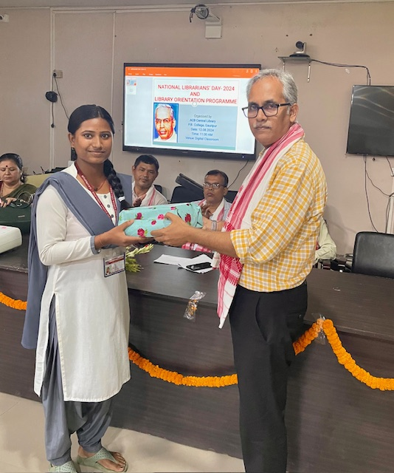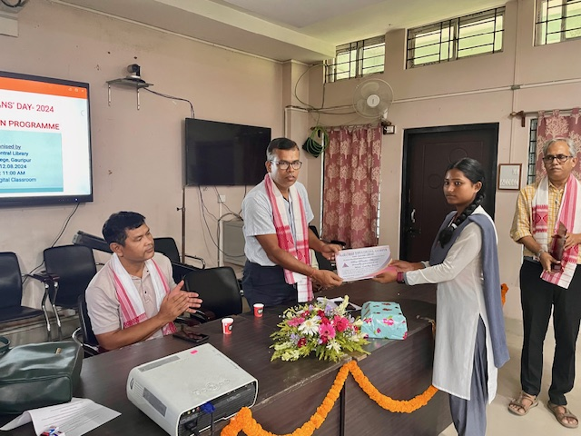
The Best Reader Award is given in the memory of Debesh Biswas who was the founder Librarian of P B College and an ardent reader. The award comprises a memento, a certificate and a gift packet of books. It is given to encourage students to visit library and make the optimum use of it and inculcate in them a love for reading. The Best Reader is selected by the Library fraternity on the basis of frequency of visits to the library as well as the overall approach of students to the central Library.
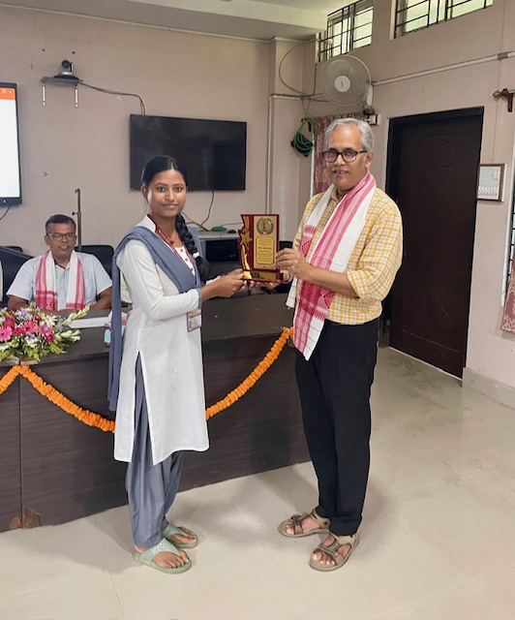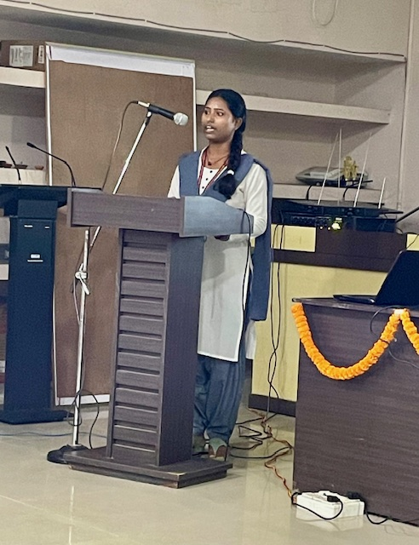
The program ended with a lecture by Lotika about her own journey towards inculcating a habit of rading and she acknowledged the contribution of the Department of Political Science and the faculty members towards encouraging her to take up reading.

