B.A 2nd Semester, 2024
Multidisciplinary Course, FYUGP
Sub: Foundation of Mathematical Science
Topic: Missing Numbers, Odd man Out, Coding & Decoding
…………………………………………………………………………………………………

Question:Determine the missing number in the given sequence
1, 3, 5, 7, 11, __, 17, 19
Solution:
Given sequence: 1, 3, 5, 7, 11, ?, 17, 19
The given sequence is in ascending order and it is a prime number list.
As we know, prime numbers are the numbers that are divisible by 1 and the number itself only.
As a result, the missing number in the sequence should be 12.
Hence, the sequence becomes 1, 3, 5, 7, 11, 13, 17, 19.
2. Find the missing number from the following?
6 | 9 | 15
8 | 12 | 20
4 | 6 | ?
Solution:
Using the row-wise logic, we can find the missing number from the given table.
The logic used here is first element in the row + second element in the row = third element in the row:
In first row, 6 + 9 = 15
In second row, 8 + 12 = 20
Similarly, in the third row, 4 + 6 = 10
Hence, the missing number is 10.
3. Find the missing number:
3 | = | 18
4 | = | 32
5 | = | 50
6 | = | 72
7 | = | ?
Solution:
Now, let us first find the relation for 3 = 18.
Thus, if we double the square of 3, we get 18.
I.e., 2 × (3²) = 2 × 9 = 18
Now, let’s check for second row:
2 × (4²) = 2 × 16 = 32
Third row: 2 × (5²) = 2 × 25 = 50
Fourth row: 2 × (6²) = 2 × 36 = 72
Similarly for fifth row: 2 × (7²) = 2 × 49 = 98
Hence, the missing number in the given table is 98.
4. Determine the missing number:
188 | 300 | 263
893 | ? | 915
Solution:
First, find the logic for the first row and apply it in the second row to find the missing number.
Logic for first row: (263 – 188) × 4 = 75 × 4 = 300.
Similarly for the second row, we get
(915 – 893) × 4 = 22 × 4 = 88.
Therefore, the missing number is 88.
5. Find the missing number: 195, 383, 575, 763, 955, ___ .
Solution:
Given sequence, 195, 383, 575, 763, 955, ___ .
Go through the given sequence from left to right.
In the given sequence, each number has three digits.
The logic used here is as follows:
- First digit of the number is increased by 2
- Second digit of the number is decreased by 1
- Third digit of the number is decreased and increased by 2 alternatively.
Hence, the missing number in the sequence is 1143.
Therefore, the sequence is 195, 383, 575, 763, 955, 1143.
6. Calculate the missing number:
6 | 1 | 5
3 | 9 | 10
4 | 3 | ?
Solution:
Row wise logic used here is First element in the row + Second element in the row – 2 = Third element in the row.
I.e., First row: 6 + 1 – 2 = 7 -2 = 5
Second row = 3 + 9 – 2 = 12 – 2 = 10
Hence, the third row = 4 + 3 – 2 = 7 – 2 = 5.
Therefore, the missing number in the third row is 5.
7. Find the missing number from the sequence: 5, 10, 13, 26, 29, 58, 61, ___.
Solution:
Given sequence: 5, 10, 13, 26, 29, 58, 61, ___.
In the given sequence, the numbers are multiplied by 2 and increased by 3 alternatively.
I.e. Second number in the sequence = 5 × 2 = 10
Third number in the sequence = 10 + 3 = 13
Fourth number in the sequence = 13 × 2 = 26
Fifth number in the sequence = 26 + 3 = 29
Sixth number in the sequence = 29 × 2 = 58
Seventh number in the sequence = 58 + 3 = 61
Hence, the eight number in the sequence = 61 × 2 = 122.
Thus, the missing number is 122.
So, the sequence is 5, 10, 13, 26, 29, 58, 61, 122.
8. Compute the missing number in the sequence: 1, 8, 27, 64, ___, 216.
Solution:
Given sequence: 1, 8, 27, 64, ___, 216.
The logic used here is the cube of the natural number
1³ = 1
2³ = 8
3³ = 27
4³ = 64
5³ = 125
6³ = 216
Thus, the missing number is 125.
Hence, the given sequence is 1, 8, 27, 64, 125, 216.
9. Find the missing number:
2 | 8 | 9
3 | 2 | 4
3 | 6 | ?
Solution:
The rows follow a sequence of square numbers such as 17², 18², and 19², if we read each row as a three digit number.
I.e. = 17² = 289
18² = 324
19² = 361.
Hence, the missing number is 1.
10. What number should come next in the sequence 22, 21, 23, 22, 24, 23, __.
Solution:
Given Sequence: 22, 21, 23, 22, 24, 23, __.
In the given sequence, the numbers are decreased by 1 and increased by 2 alternatively.
First number: 22
Second number = 22 – 1 = 21
Third number = 21 +2 = 23
Fourth number = 23 – 1 = 22
Fifth number = 22 + 2 = 24
Sixth number = 24 – 1 = 23
Seventh number = 23 + 2 = 25.

Practice Questions
- Find the missing number in the sequence: 53, 53, 40, 40, 27, 27, ___.
- Determine the missing number:
2 | 6 | 18
4 | 20 | 100
? | 21 | 147
- Find the missing number in the sequence: 664, 332, 340, 170, ____, 89.

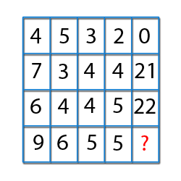

Logic:
Column-Wise
(First Column Element × 4th Column element) - (2nd column element + 3rd Column element) = Last Column Element
(4×2)-(5+3) = 0
(7×4)-(3+4) = 21
(6×5)-(4+4) = 22
(9×5)-(6+5) = 34.
- Find the missing number
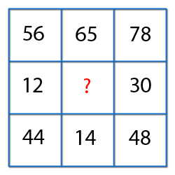
Logic:
First Row Element - Third Row Element = Second Row Element.
56 - 44 = 12
65 - 14 = 51
78 - 48 = 30.
Hence, in the missing number should be 51.
- Find the missing number

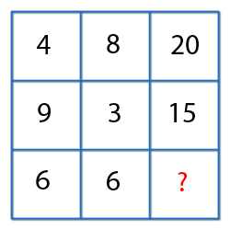
20 = 8 x 2 + 4
15 = 3 x 2 + 9
Hence,
The number on the blank space,
6 x 2 + 6 = 18.

- Find the missing term

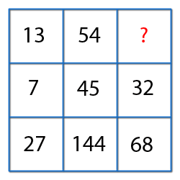

In the first column,
27- 7 X 2 = 13
In the second column,
144 – 45 X 2 = 54
So,
in the third column,
68 -32 X 2 = 4

- Find the missing term
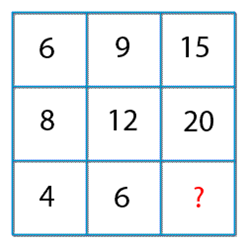

Logic:
First element + second element = Third Element.
6 + 9 = 15
8 + 12 = 20
4 + 6 = 10
So, required number is 10.

- Find the missing number?

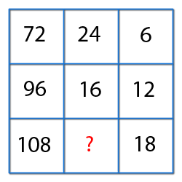

Logic (Row-wise):
(First Element / Second element) * 2 = Third Element.
So,
(108/x) * 2 = 18
x = 12.
Missing Number = 12.

- Find the missing number
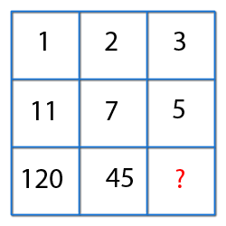
Logic:

First column => 11² - 1² = 120.
Second Column => 7² - 2² = 45.
Third column => 5² - 3² = 16

- Find the missing number

1, 4, 27, 16, ? , 36, 343
Solutions: Clearly, the given series consists of cubes of odd numbers and squares of even numbers, i.e 1³, 2², 3³, 4²
So, missing term 5³ = 125
- Find the missing term

4, 6, 12, 14, 28, 30, ?
Solutions: The given sequence is a combination of two series:
- 4, 12, 28, ?andii. 6, 14, 30, ……….
Now the pattern followed in each of the above two series is: +8, +16, +32
So, the missing number = (28 +32)= 60
- Find the missing number

1, 3, 3, 6, 7, 9, ?, 12, 21
Solutions: The given sequence is a combination of two series:
- 1, 3, 7, ?, 21 and ii. 3, 6, 9, 12 ……….
Now the pattern followed in (i) is +2, +4, ………………
And the pattern followed in (ii) is +3
So, the missing number = (7 +6)= 13
- Find the next two terms in the series

  - A, C, F, J, ?, ? Ans. O, U
  - R, U, X, A, D, ? Ans. G
  - T, R, P, N, L,?, ? Ans. J, H

- Find the missing term

  - 4: 17 :: 7: ? Ans.50
  - 2: 32 :: 3 ? Ans. 243 Hints: 2⁵ =32 & 3⁵= 243

Coding and Decoding:
Question: If in a certain code, LUTE is written as MUTE and FATE is written as GATE, then how will BLUE be written in that code.
- CLUE b. GLUE c. FLUE d. SLUE
Question: In a certain language, MADRAS is coded as NBESBT, how is BOMBAY coded in that language.
- CPNCBX b. CPNCBZ c. CPOCBZ d. CQOCBZ
Question: If FISH is written as EHRG in a certain code, how would JUNGLE be written in that code?
- ITMFKD b. ITNFKD c. KVOHMF d. TIMFKD
Question: In a certain code, ROAD is written as URDG. How is SWAN written in that code?
- VXDQ b. VZDQ c. VZCP d. UXDQ

Odd man out and series:
Question: Find the Odd ones 3, 5, 11, 14, 17, 21
- 21
- 17
- 14
- 3

Answer: Option iii
Explanation:
Each of the numbers except 14 is an odd number.
The number '14' is the only EVEN number.
Questions: Find the Odd ones of 27, 64, 100, 125, 216, 343
- 27
- 100
- 125
- 343
Answer: Option ii
Explanation:
The pattern is 2³, 3³, 4³, 5³, 6³, 7³. But, 100 is not a perfect cube.
Question: Find the Odd one 10, 25, 45, 54, 60, 75, 80
- 10
- 45
- 54
- 75
Answer: Option iii
Explanation:
Each of the numbers except 54 is multiple of 5.
Question: Find the odd one 6, 9, 15, 21, 24, 28, 30
- 28
- 21
- 24
- 30

Answer: Option( i)
Explanation:
Each of the numbers except 28, is a multiple of 3.
Question: Find the Odd one 41, 43, 47, 53, 61, 71, 73, 81
- 61
- 71
- 73
- 81

Answer: Option (iv)
Explanation:
Each of the numbers except 81 is a prime number.

